Newsletter of the Romford United Reformed Churches at Western Road and Heaton Way
December 2020

KINDLE
Minister’s Letter
Dear Friends,
Christmas 2020 is probably one we will never forget as it has been so unusual. Plans changed at the last minute, very limited gatherings, restrictions on travel have been the experience of all society. Yet the message of Christmas has remained the same, Christ is born among us and for us. I hope the fact that this Christmas has been different will mean that more people will have realised what is important about Christ-mas.
I suppose the same could be said of 2020 as a whole, the pandemic with lockdowns and restrictions has made people realise what is important in life, our relationships with each other and even though at times we have been isolated and we are still socially distanced in public places, many of those relationships have grown and strengthened. I hope the same is true of our relationship with God as we look back over a year that has been so different and difficult for many.
2020 has also brought out the best and the worst in people – the selfless work of those in the NHS/Care sector and the emergency services; the wonderful spirit of volunteering; the growth of community spirit and getting to know neighbours against the selfishness of panic buying and stock piling; the casual disregard of restrictions in place to ensure everyone’s safety. Let’s hope we all take to heart what this year’s events have shown us about ourselves and our society.
So what does 2021 hold for us? Initially we all know that we will still be living with the pandemic and its effects, but as the vaccination programme is rolled out, that will change, although I think mask wearing and social distancing will be with us for quite some time into the New Year. With regards to other things, we don’t know but we expect times of celebration and joy along with times of sorrow and difficulty, but in all that we experience we can go forward believing that God is with us, taking the hope of Christmas with us.
2021 will be a different year - in what ways we don’t know but we will all have our hopes, dreams and expectations. Some will be fulfilled during the year in others we may be disappointed, but that is the warp and weft or life. Often as the year turns I come back to words from Julian of Norwich “ all shall be well and all shall be well and all manner of things shall be well”. These words show Julian’s amazing trust in the promises and presence of God.
Finally thank you all for the lovely Christmas cards I received and I wish you all an Happy New Year with God’s blessings.
“all shall be well and all shall be well and all manner of things shall be well”.
Alison

……………………………………..

Zoom Services
I am filled with admiration for the members of our congregation who have shared in our Advent Services in so many ways. Of course, I knew you all could read but it is a different matter sharing in a Zoom Service and getting to press the right mute/unmute button at the right time. So an enormous thank you to you all and of course, to Alison, Lee and Sylvia and to Fiona for their valuable parts in delivering our worship
I have just been talking to Averil, Neil, Tom, and Helen on a practice Zoom for Boxing Day when we hope to have Claire and Jo's family as well. I know that many of you have been doing this all along. but with my reluctance with things computer, I have finally been dragged forward. Let us hope it works, we are going to pull crackers and open our presents as well.

My neighbour and I have delivered an invitation to all the houses in the street asking them to come out with a cup of coffee or glass of wine and a mince pie on Wednesday evening to greet each other sharing Christmas greetings . Then I saw on the news that the suggestion has been made to ring a bell on Christmas Eve, so perhaps we will do that as well. I have had a good response from people as I walk Faith so we will see.

The next Kindle will mean we will be very nearly in the New Year. We will be hoping and praying that 2021 will be different and with more things to celebrate. Annette and I were talking about the possibility of having a Church Diary soon! We can wait a while.
……………………………………..

, Please, please, please

Has any one seen the other white box with posters in it ? There is still one in the Trustees Office but there used to be two The missing one has the most useful posters in it. I have just ordered some new ones for next year but at nearly £5 a time it can be an expensive issue to replace the ones we had. So if you can think where the box might have gone please let Gill know.
……………………………………..
Another request....................if you drink Acteme can you please save the little bottles. My hope is that we can fix them onto the cross, fill them with water so our Easter flowers last longer. If you have please let Gill have them.

Gill
……………………………………..

Natural Entertainment
We have a room at the back of the house that overlooks the garden and an abundance of trees. The room has a large window where we have fixed, by suction pads, a square bird box, which we keep filled with bird peanuts. We sit in this room to have our morning coffee and are entertained by birds coming to feed. They are mostly bluetits, and some have different colouring, but they never stop long enough to enable us to work out the variety that they are. They have a routine and fly from a fir tree on the left-hand side, onto a shrub underneath the big window, then wait a moment before hopping up into the bird box. They quickly take a nut and fly back into the fir tree to enjoy the feast. Sometimes they are so hungry that they queue up and come one after another! Lately there has been a sparrow doing the same routine. We also have a seed tray hanging outside Tom’s workshop. And watch as squirrels, pigeons and a robin enjoy the contents. There are other birds as well including magpies, blackbirds, starlings and two moorhens, which come to peck on the grass. So, we have built-in entertainment for free! Tom And Betty
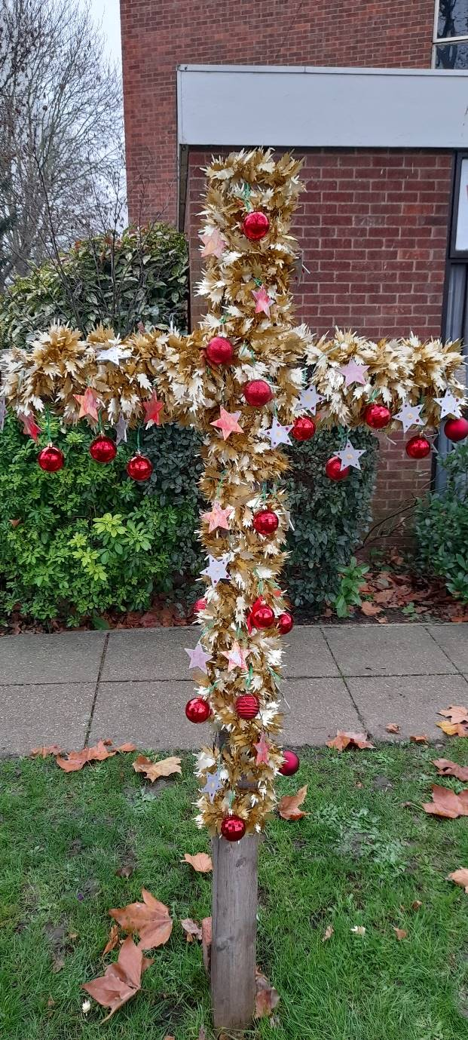
Decorating the outside of the church for Christmas
A group of us met at the end of November to help put up the nativity figures and decorate the cross. With a group of people to help it was all done relatively quickly and we thank everyone who helped. Stars were strung in the trees along the drive and a Christmas tree and knitted nativity figures in the foyer can be seen through the window near the kitchen.
Thank you again to all those who helped.

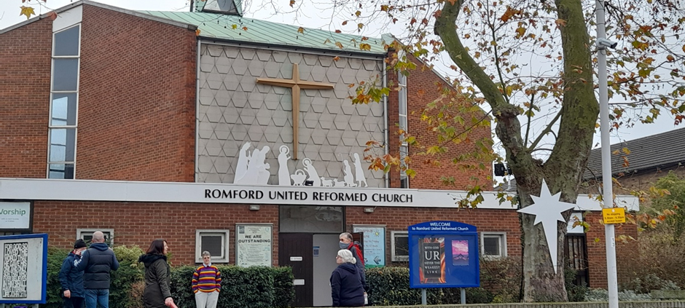

…………………………………..

In May I sent in a prayer that came from my Tearfund Lent reflections all about hope it has remained on my kitchen cupboard all through this year and I would urge to look it up again but meanwhile this has also come from Tearfund as part of their Advent reflections and again I find it both encouraging and challenging for these times and as we move into a New Year which seems to have started much as the last ended.
We need to know that our hope is in a God who is Immanuel - God is with us
Tearfund, is an organisation that is fuelled by hope. Not a hope of wishful thinking or false optimism, but one that is grounded in the certainty of God’s goodness.

Our present: hope
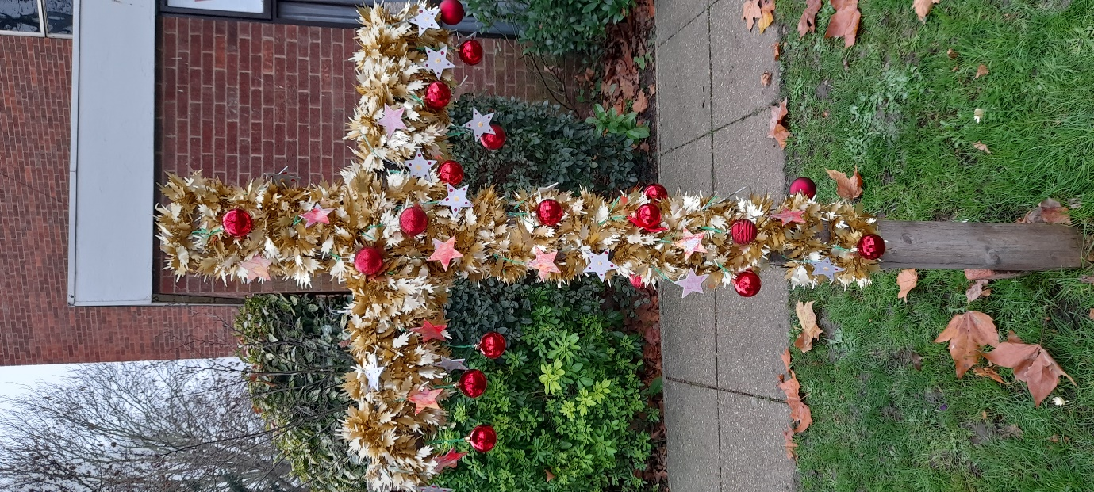
Nothing levels the playing field of humanity like a global pandemic or tragedy…
In our out-of-control fragility, we yield ourselves to humility –
powerless to change the circumstance, but grace reveals a second chance.
The time we thought that we controlled
reveals what’s hidden in our souls.
If it were up to the TV
then all we’d see is the collapse of all security –
industry, economy, family –
overwhelmed by the waves of uncertainty…
day by day in our present reality.

And the loss is real and felt worldwide –
finance, funerals, weddings:
the scattered church bride.
The rules and restrictions affect my freedoms physically
but the greatest freedom that I know abides inside of me
and it’s by this revelation that I’m saved and whole and free –
the Son of God in human flesh, born as a child for me!

Heaven was not the present but that the King of Life came down,
my living hope now and forever,
anchors my mind in places sound.
I don’t know the future but he’s in it, in that assurance I won’t fear!
Every trial: I’ll break through it, knowing heaven’s help is near.

We’ve never needed each other more on the shores of uncertainty –
yet I see kindness breaking forth that unites communities.
The poor, widowed and vulnerable have joined back in the race,
holding hands of hope with strangers who provide for them a place.

I feel excitement bubbling, the stirring in my bones –
this hope that seeks and saves the lost brings many sons back home.

Hope makes me a dreamer in a technicoloured coat –
hope in the Great Redeemer: the perfect antidote.
What if our setbacks were our set ups?
And our pain platforms of grace?
Maybe we would keep our judgments to ourselves
with smiles upon our face –
knowing we all fall short and need this hope.
So let’s give it away…
piece by piece a slow release till it floods, till it sustains.

For the battle is not these carnal things by weapons that I hold,
but on my knees with prayer and thanksgiving my arsenal unfolds!
And from my King’s perspective, priorities align –
where we got misdirected, our purpose redefined.

We become what we behold, our power is we choose
to reflect perfect love and needed hope
or the fears shown in the news.
In a world that needs, but breaks, our light we disperse in many colours
the spectrum of life just like our Christ
a hope for many others.

‘Out of his fullness we have all received grace in place of grace already given. For the law was given through Moses; grace and truth came through Jesus Christ. No one has ever seen God, but the one and only Son, who is himself God and is in closest relationship with the Father, has made him known.’ (John 1:16-18)

‘Yes, my soul, find rest in God; my hope comes from him. Truly he is my rock and my salvation; he is my fortress; I shall not be shaken.’ (Psalm 62:5-6)

I come to you God and I place before you my dreams,
My hurts and fears, my failures and my doubts,
I lay them down at your feet, where I know they are held.
It may look foolish to the world, it may not make much sense,
But I know the bigger story, I know what’s to come.
In this world of fear, I choose hope,
In this world of anger, I choose forgiveness,
In this world of exclusion, I choose love,
In this world of distraction, I choose you.
Remind me of your truth Lord, especially in the waiting,
When times are hard and I’m struggling to hear your voice.
Fill me afresh with your presence, remind me of your great plan,
And let the truth sink in that I need only you. Amen
Ruth Mitchell

Christmas Quiz- Answers
1. 1843 – a man called John Calcott Horsley printed the first Christmas card for the friend that gave him the idea, Sir Henry Cole.
2. Norway – the city of Oslo, Norway, donates the Trafalgar Square Christmas tree to the people of Britain each year since 1947.
3. It was started by The Queen’s grandfather, King George V, in 1932.
4. 1984
5. Robins because they represent postmen who used to wear red coats.
6. The Merry Wives of Windsor
7. Hungary
8. The Stone of Scone – on Christmas Day 1950, four students took the stone from Westminster Abbey in London back to Scotland. The 2008 film called Stone of Destiny illustrates the incident.
9. Egypt
10. Saint Stephen
11. January 7th – the Russian Orthodox Church uses the old ‘Julian’ calendar for religious celebration days. Only a few Catholics might celebrate it on the 25th of December.
12. Oliver Cromwell
13. To and from.
14. The Romans
15. The Druids
16. Blitzen, Comet, Cupid, Dasher, Prancer, Vixen, Dancer, and Donner
17. Arnold Schwarzenegger
18. The Snow Queen?
19. Elvis Presley
20. We wish you a Merry Christmas
21. The tradition of wishing neighbours a long life.
22 St Francis of Assisi
23. Beef and spices
24. Tangerines
25. A sort of mulled wine

Minister
Rev’d Alison Davis 01708 727955
Davisalisonm7@gmail.com

Church Secretary Western Road
Gill Shepherd Gillianshepherd2003@yahoo.co.uk

Church Secretary Heaton Way
Louise Manning
01708 344832 e.manning@ntlworld.com
_______________
Kindle
robinmorrison21@outlook.com
copy for net issue 25th January 2021

